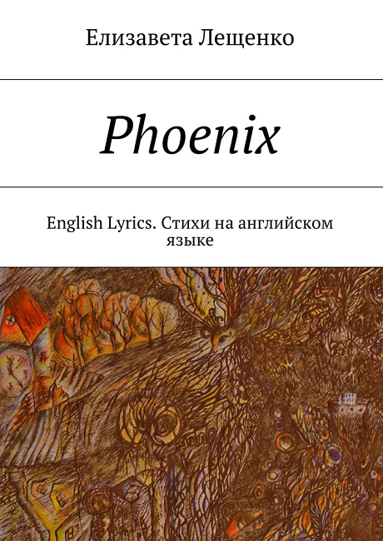

Елизавета Лещенко

Phoenix

English Lyrics. Стихи на английском языке

Fonts by «ParaType»

Proofreader Tedo Gogichashvili

Illustrator Елизавета Лещенко

© Елизавета Лещенко, 2017

© Елизавета Лещенко, illustrations, 2017

Sometimes I feel the whole world inside. It is born, and then it grows and explodes… And then there will be a new little world instead of the old ones — like live fire, like a gentle phoenix.

ISBN 978-5-4483-8954-2

Created with Ridero smart publishing system

Contents

• Phoenix

• I like your eyes

• Wish Tree

• Lilac-blue evening

• Night hunting

• Conjurer

• Inside me

• Mompracem

• Sailing ships

• Phoenix

• Rose flower

• Little man on my palm

• Light plumelet

• Black-and-white film

• Here is a woman

• Little paper shadoof

• Be with yours

• The Little Sun

• How do you see…

• Lothlorien

• Wonderwork

• The gray bird

• Just come up

• Aim

• Dusty mike

• But I need it so

• There are

• The emerald bird

• He was and She was

• White-Butterfly’s wave

• Stratosphere

• Between

• Black and white rose

I like your eyes

I like your eyes when they’re looking in these lakes,

like there’re riveres made of star gems,

lying here

I like your hands when they’re getting all these stones,

like they have inside all the truth about this way in its void

or its incoming shores

I love your muted voice when it is crying from the vault

like birds of catacombs, who splintering their hearts

against this cruel highness

I love to were your well-worn close,

because they heats my hopeless chords

Wish Tree

The tree has dried up, but in the night breeze brightly colored  
 tapes fluttering flickered,

And the strange birds quietly sing their magic songs.

My heart is pounding because still able to love beauty.

Lilac-blue evening

There is a magical lilac-blue evening, which hidden in paper haze of childlike picture.  
Let’s go, let’s go with me to there.

There is a coral dawning, which embraces naked fingers by warm surf,   
and there is a sand, which smells like sky tenderness.

Let’s go, let’s go with me to there.

Night hunting

Ancient birds silently look at the stars through the deep foliage.

Young Tigers go on night hunting in foreign forests.

Conjurer

I tamed little fabric butterflies by singing about a homely autumn.

I kicked away mechanical tigers by showing them fabric butterflies.

Inside me

Inside me is unusual tree, whose leaves and roots are disagreeing.

And there is Small Butterfly, which has its own sky.

Mompracem

My unfinished Sand Castle, my Little Mompracem,  
 I wish you to be forever untouched, to be not desecrated   
by anyone’s banner. I only wish you to be lulled to sleep  
 by clean waves of heart beating.

Sailing ships

I am learning to paint your colors

In order to my characters

could stand right on the stave

I’m saving the grains of sand and stones

for protecting your shores

In order to my sailing ships

would float right on by wind

Phoenix

Gentle Phoenix, sleeping

in twinkling blue floret,

your house have kept my flames,

your ageless song is shouting its sooth.

Sitting on airless coast,

Hidden my soles in the sand,

I hold you in arms, and favor your breath —

in contact with youth

Rose flower

I will pluck a rose flower,

which grows near your former house, and I will put it in a pocket of the

heart.

My petals gently touch your cheek every night.

Little man on my palm

The little man is

dancing on the palm of my hand

The little man

tries to escape

I feed him bread

I water him milk —

He doesn’t want anything else to know

The little man

grew up and got stronger

I am attached to the little man

but he wouldn’t stay longer

Light plumelet

Light plumelet flying in the wind,

just above the ground, just below the clouds.

Light plumelet has no outlines and no colors,

Without the weight and the name of —

its path is as follows…

Black-and-white film

From a small cabinet of self

You see the world as black and white, baby

Oh yes, this movie is for people just like you

Colored wonders will never place

in your little box, honey

and all I have to say is “I’m so, so thankful, for you, Babe”

Here is a woman

Here is a woman

who could be clean and beautiful

She see the crack in all that touch

Her empty eyes

Here is the road which could lead you home

It makes a dusty circle and back right to dead point

Little paper shadoof

Little paper shadoof

fell asleep on the floor

His weak wings get crushed of heavy dust

He’ll never know the warmth of your hands

and will not see the emerald sky

Be with yours

Just let the wind ruffle your hair,

Just let your foots step on

Wet sand —

Where they wants

By the way —

Be the Water, be the Way,

Be with yours

The Little Sun

The little shiny sun,

which beats upon my skin,

Is doing something fun

And tries to go within.

Its little looking glass

Plays as cats & mouse.

How do you see…

How do you see the sky today?

Are there sailing ships of ancient half-birds

and are there unquenchable stars

which give you their shining and way?

Are there night noise in your breath

and are there the person who knows my Mysteria?

Lothlorien

Please save for me Lothlorien’s bloom and silver-gold,

grant me your maple leave

for I could colore autumn sky in lilac-purple cold

Divide with me your inmost bread

for I could learn make fire-salt

and for snowflake‘s shamanic dance

right thru and over our bed

Wonderwork

Let me see this wonderwork just once again:

when you are my verve,

where I am your flame,

just as wind is so chaste

and the stones sing just truth — not the pain

The gray bird

Gray The Bird, the silver gold

Your clear eyes are full of hope and sadness

The fragile and untouchable gray bird,

Your wings become the cloudy evening of my silence

Just come up

When there will be the end of all words, sounds and outlines,

Just come up and embrace me

When all the rivers will flow away and no one bird will fly back to these places,

Just come up and embrace me

When the silence will become so loud and you couldn’t hear my songs,

Just come up

Aim

Girl, shooting at rain without an aim,

What is the wet sand,

where your name

is told?

Girl, decomposing herself for a rainbow,

colors, which making you glow,

are blue,

as my basic Hot-Cold

Dusty mike

My dusty mike,

you broadcast sacred silence into mute ether,

I whisper my breath near your ear, and you’re smiling so confused

and answer as an crack

But I need it so

And now I haven’t illusions,

but I need it so.

It would not be conclusion

or any firm low.

I must paint you a message,

you could drive me to way:

to stick fast in this passage,

to return run to stay

There are

There are my fields and my mists —

on my palm

or in fist

The emerald bird

Little bird, the emerald bird of my sunshine,

Please, tell me that the water

which falls by this rain

is alive

And please, tell me that the song which

is sounding right now, is not your swansong

He was and She was

He was

and

She was —

but that’s just a dose

And he was a flame,

and she was a frost,

but was it a warm —

just Nobody knows

And she was a song,

and he was a noise,

but was it a record —

just Someone resolves

And there were whole world

and emptiness — toys,

and Everyone knows

what was their choice

White-Butterfly’s wave

Here was a White-Butterfly’s wave, which glimpsed behind my window-glass — during split second, just making its passing

I swear, I saw you, White-Butterfly’s wave

on Eternity Blade,

and thank you for possible-blow,

which you gave me

for

I could be waiting

Stratosphere

Your dandelions are frozen in their greenhouses.

Your bare feet are stuck in their pavement up to the neck.

Your head in the stratosphere is much higher than their buildings.

Between

My spirit soars, where seagull’s trace is,

Between the sail and shy sunrise,

Between moon’s salt and coast’s stardust are,

Between your cry and my repose

Black and white rose

Black and white rose of purple evening,

reveal for me your petals

for showing me your heart.

Lilac star of black and white dawn,

don’t let me fall

before I try this dust.